**ACKNOWLEDGEMENT**

First and foremost, a big thanks to Almighty God, for the blessings that he showered upon throughout the capstone project and its successful completion.

The researchers also want to express their deep appreciation to **Mr. Jodell Bulaclac**, their research adviser, for his outstanding guidance, support, and supervision throughout the capstone project. They also want to thank him for teaching and for his empathy, patience, and wisdom. Being able to work and study under his direction was a huge honor and privilege.

The researchers would also like to thank their panel, **(Name of panel)**, for their insightful recommendations that helped to direct and improve the results of the capstone project.

To the researchers they would like to thank **Mr. Christian B. Peña**, their capstone instructor, for his guidance, support, and patience throughout the completion of the capstone project. Thank you!

In addition, the researchers would like to thank some of the faculty members in **(school name)** who contributed to the enhancement of the capstone project. To the faculty and staff member who volunteered their time resulting in comments and recommendations that greatly improved the tools used in this study. Thank you as well!

To **Dr. Albert C. Bulawat,** head of NEUST papaya off campus, thank you for support to all the students.

Last but not least, they would like to thank their dearest parents for their thoughtful finances and constant encouragement throughout the creation of the capstone project. Additionally, they are grateful for their words of support during all the late nights that they spent working on the capstone project.

**DEDICATION**

This capstone project is dedicated to the staff and faculty of ( school name),to easy track and monitor their attendance and managing class schedule.

To parents, friends, teacher and classmates who shared their words of advice and encouragement to finish this capstone project.

And specially to our Almighty God , thank you for the guidance , strength, power of mind , protection and skills . All of these we offer to you .

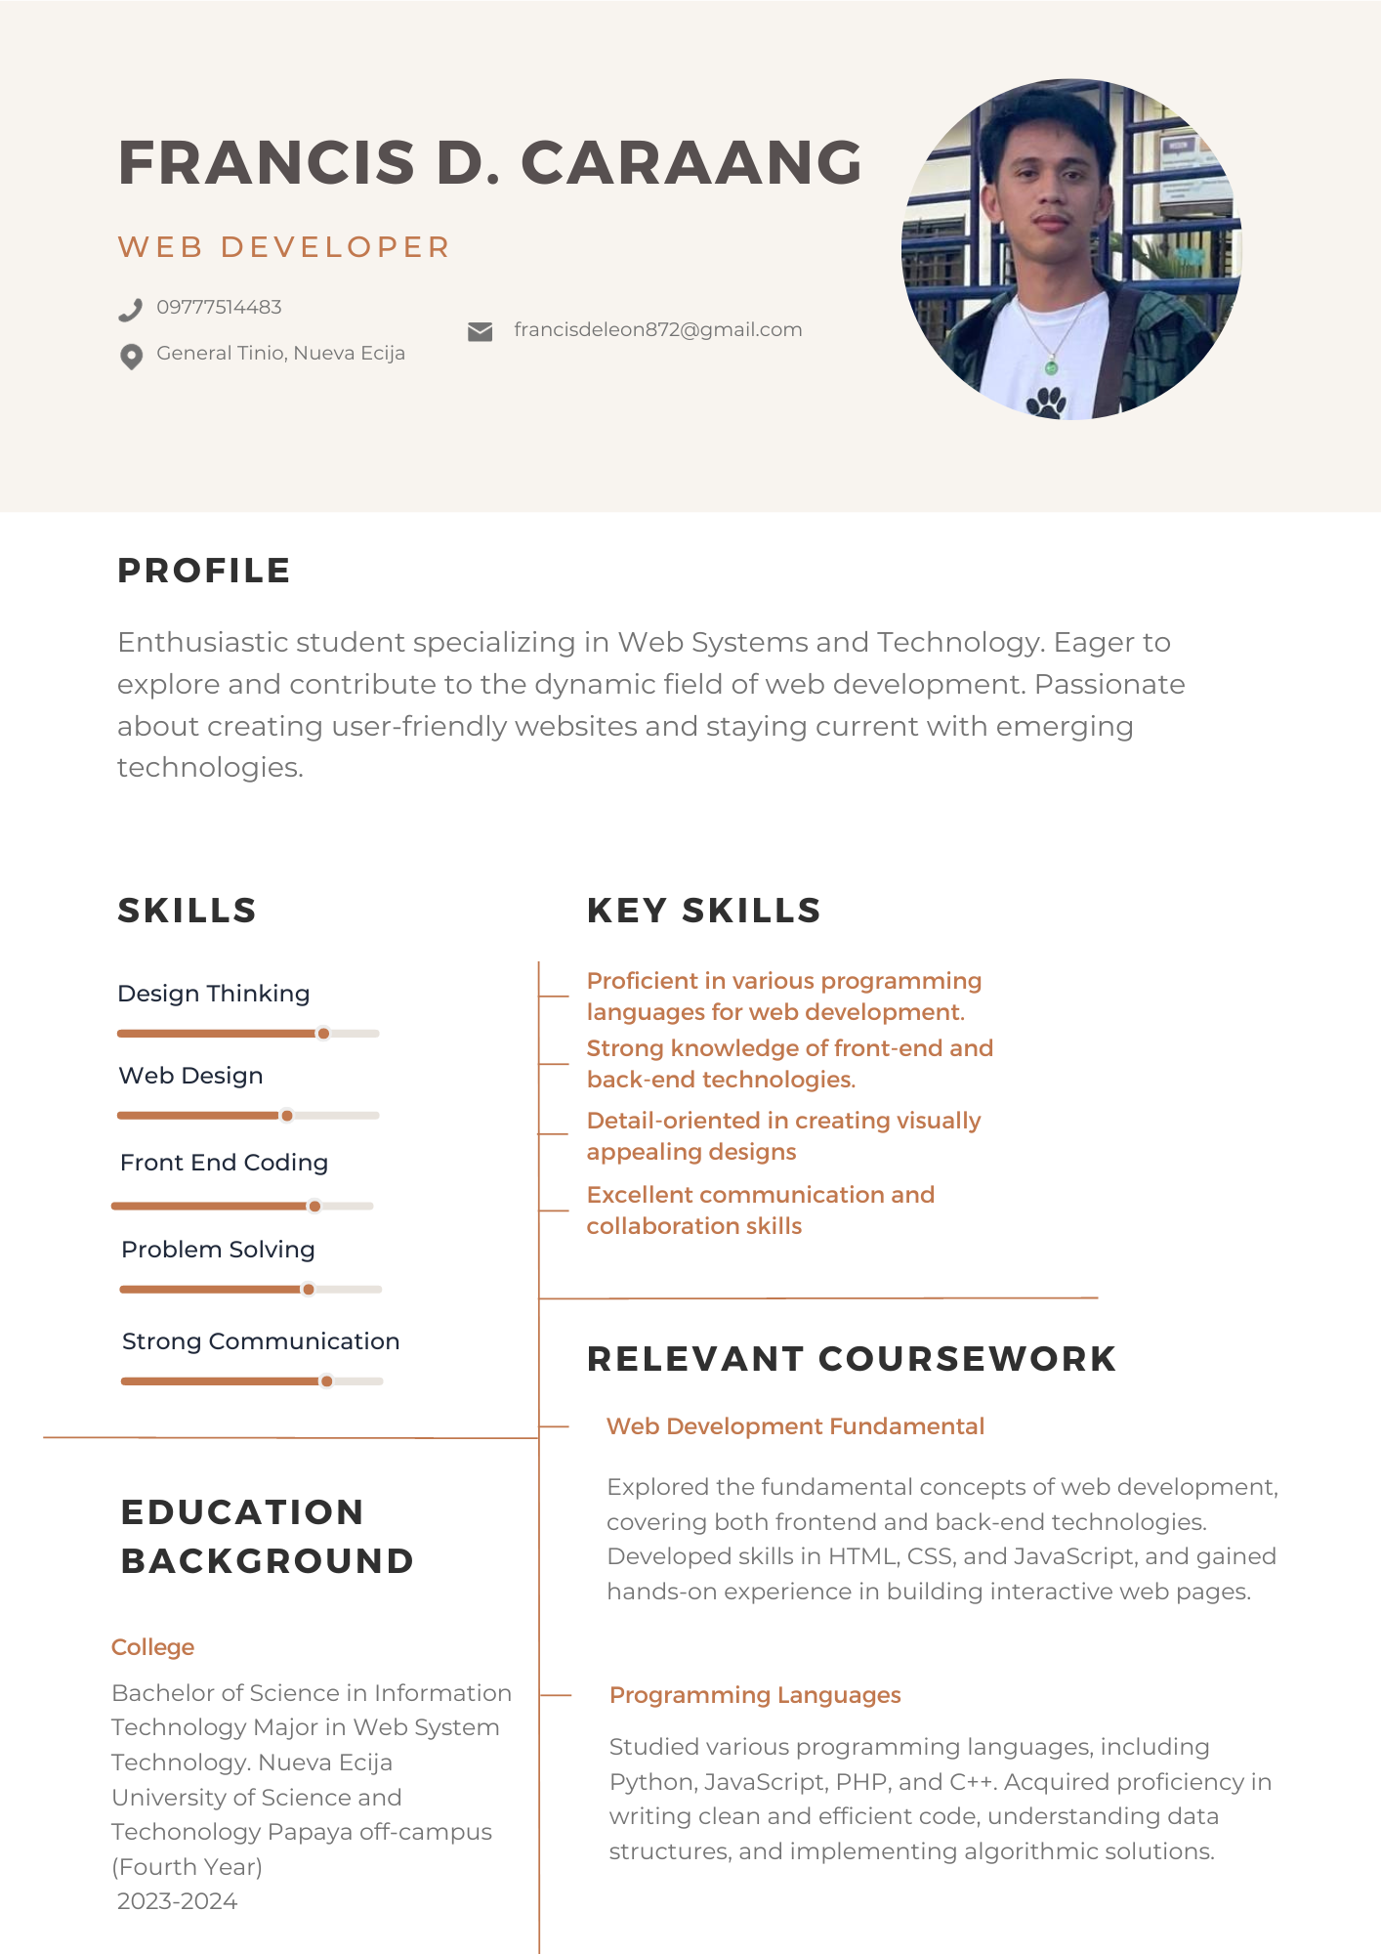**Curriculum Vitae**

